WEB-ACTIVITY
NAME : PALISATTI REETHU PRIYA
REGISTRATION NUMBER : 26001509
SECTION : AIML-1
CASE : 2
College Information and Admissions Website Design a college website displaying institutional information, departments, courses, faculty profiles, admissions procedures, campus facilities, events, and contact details. Create a navigation bar, banner, and responsive information cards.
INPUT :
<!DOCTYPE html>
<html>
<head>
<meta name="viewport" content="width=device-width, initial-scale=1">
<title>NRI College - 26001609</title>
<style>
body
{font-family:Arial;margin:0;background:#f8f9fa}
header{background:#c0392b;color:#fff;padding:15px;text-align:center}
nav{background:#fff;display:flex;gap:10px;padding:10px;justify-content:center;box-shadow:0 2px 5px #ccc}
.card{background:#fff;margin:12px;padding:15px;border-radius:10px;box-shadow:0 2px 5px #ccc}
.grid{display:grid;grid-template-columns:1fr 1fr;gap:10px}
.btn{background:#c0392b;color:#fff;border:none;padding:8px 12px;border-radius:5px}
</style>
</head>
<body>
<header>
<h2>Dr. RVR NRI INSTITUTE OF TECHNOLOGY</h2>
<p>26001609 - REETHUPRIYA - AIML</p>
</header>
<nav>
<b>Home</b> | Departments | Courses | Admissions | Contact</nav>
<div class="card"><h3>Welcome to NRI</h3>
<p>An Institution deemed to be University u/s 3 of UGC Act, 1956</p>
<button class="btn">Apply Now</button>
</div>
<div class="grid">
<div class="card">
<h4>CSE - AIML</h4>
<p>Intake: 180 | AI & Machine Learning</p>
</div>
<div class="card">
<h4>CSE</h4>
<p>Intake: 240 | Core Computer Science</p>
</div>
<div class="card">
<h4>ECE</h4>
<p>Faculty: Dr. Rao | Labs: 12</p>
</div>
<div class="card">
<h4>Facilities</h4>
<p>Library, Hostel, Canteen, Transport</p>
</div>
</div>
<div class="card">
<h3>Contact: info@nriit.edu.in | 9640334422</h3>
</div>
</body>
</html>
OUT PUT: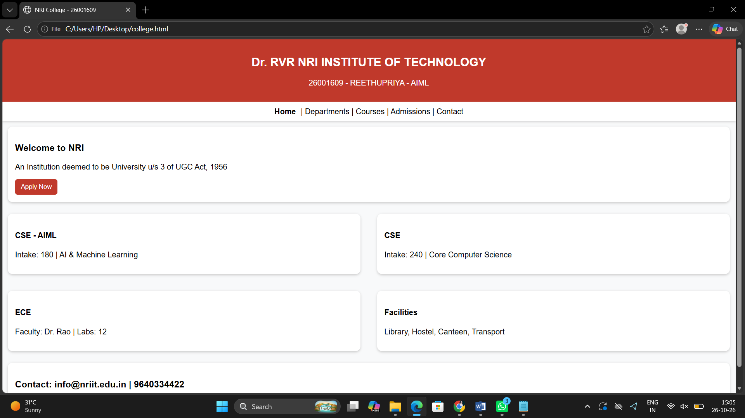

CASE:4.

Student Academic Dashboard Create a dashboard displaying student details, semester results, attendance percentages, subject information, examination schedules, and announcements. Use tables, progress bars, cards, and a sidebar layout.

<!DOCTYPE html>
<html>
<head>
<meta name="viewport" content="width=device-width, initial-scale=1">
<title>Dashboard - 26001609</title>
<style>
Body
{font-family:Arial;margin:0;background:#eef2f7;display:flex}
.side{width:200px;background:#2c3e50;color:#fff;padding:15px;min-height:100vh}
.main{flex:1;padding:15px}
.card{background:#fff;padding:12px;border-radius:10px;margin:10px 0;box-shadow:0 2px 5px #ccc}
table{width:100%;border-collapse:collapse}
td,th{border:1px solid #ddd;padding:8px}
th{background:#2c3e50;color:#fff}
.bar{background:#ddd;height:10px;border-radius:5px}
.fill{background:#27ae60;height:10px;border-radius:5px}
</style>
</head>
<body>
<div class="side"><h3>NRI Student</h3>
<p>26001609<br>REETHUPRIYA<br>AIML<br><br>Dashboard<br>Results<br>Attendance<br>Exams</p>
</div>
<div class="main">
<h2>Student Academic Dashboard</h2>
<div class="card"><b>Name:</b> REETHUPRIYA | <b>Roll:</b> 26001609 | <b>Branch:</b> AIML</div>
<div class="card"><h3>Semester Results</h3>
<table><tr><th>Subject</th><th>Marks</th><th>Grade</th></tr><tr><td>Web Development</td><td>92</td><td>A+</td></tr><tr><td>AI & ML</td><td>88</td><td>A</td></tr><tr><td>Python</td><td>95</td><td>O</td></tr></table></div>
<div class="card"><h3>Attendance - 85%</h3><div class="bar"><div class="fill" style="width:85%"></div></div></div>
<div class="card"><h3>Exam Schedule</h3>
<p>WD ABL - Nov 15 | AIML Lab - Nov 18</p>
</div>
</div>
</body>
</html>

OUTPUT :

- 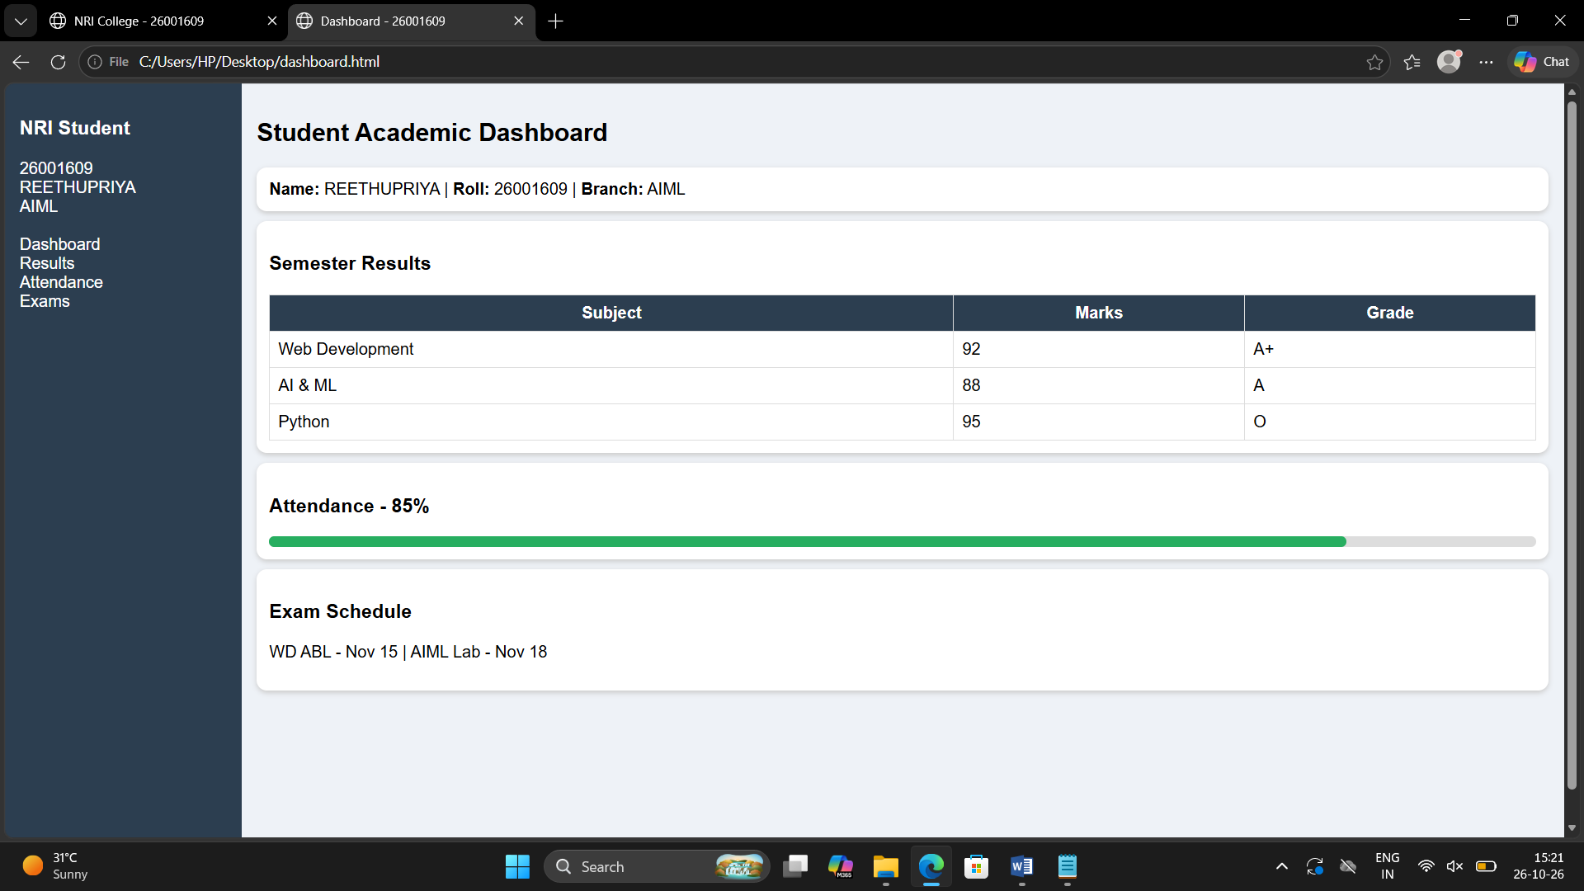
CASE : 6
Online Shopping Website Create an e-commerce interface displaying products, prices, discounts, ratings, categories, product descriptions, and shopping buttons. Design a responsive product grid, promotional banners, and a shopping navigation bar.

INPUT :
<!DOCTYPE html>
<html>
<head>
<meta name="viewport" content="width=device-width, initial-scale=1">
<title>NRI Shop - 26001609</title>
<style>
body
{font-family:Arial;margin:0;background:#f5f5f5}
header{background:#0d6efd;color:#fff;padding:15px;text-align:center}
.grid{display:grid;grid-template-columns:1fr 1fr;gap:10px;padding:15px}
.card{background:#fff;border-radius:10px;padding:12px;text-align:center;box-shadow:0 2px 5px #ccc}
.btn{background:#0d6efd;color:#fff;border:none;padding:8px 12px;border-radius:5px;width:100%}
</style>
</head>
<body>
<header>
<h2>NRI Online Shopping</h2><p>26001609 REETHUPRIYA AIML | Cart: 0 | Offers: 20% OFF</p>
</header>
<div class="grid">
<div class="card">
<h3>NRI T-Shirt</h3>
<p>Rs.499 <del>Rs.699</del> | ⭐4.5</p><p>Category: Apparel</p>
<button class="btn">Add to Cart</button>
</div>
<div class="card">
<h3>NRI Hoodie</h3>
<p>Rs.999 <del>Rs.1299</del> | ⭐4.8</p>
<p>Premium Quality</p>
<button class="btn">Add to Cart</button>
</div>
<div class="card">
<h3>NRI Cap</h3>
<p>Rs.299 | ⭐4.2</p>
<p>Free Delivery</p>
<button class="btn">Add to Cart</button>
</div>
<div class="card">
<h3>NRI Backpack</h3>
<p>Rs.799 | ⭐4.7</p>
<p>For Students</p>
<button class="btn">Add to Cart</button>
</div>
</div>
</body>
</html>

OUTPUT :
